Match the Graph - Question Sheet

## Graph 1

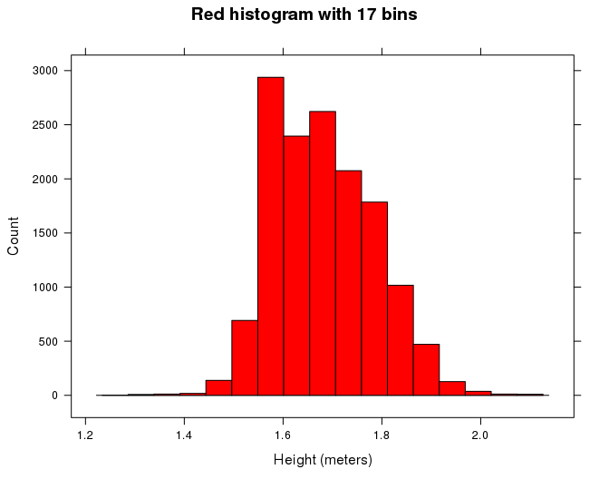

## Graph 2

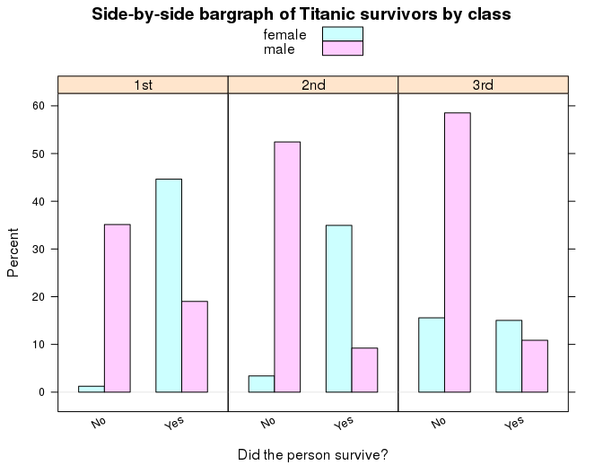

## Graph 3

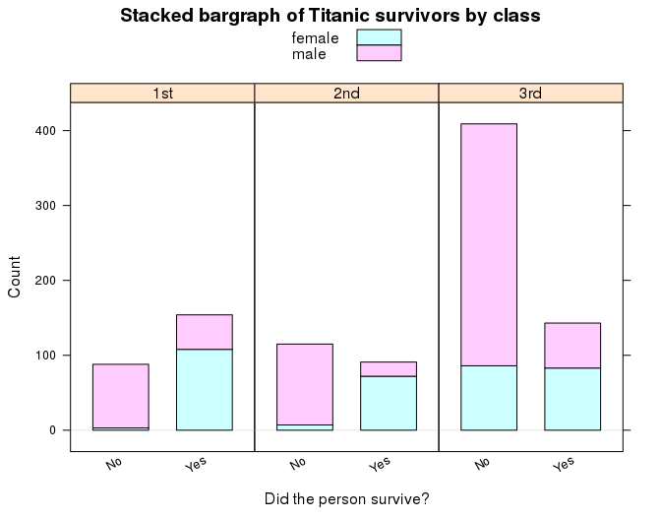

## Graph 4

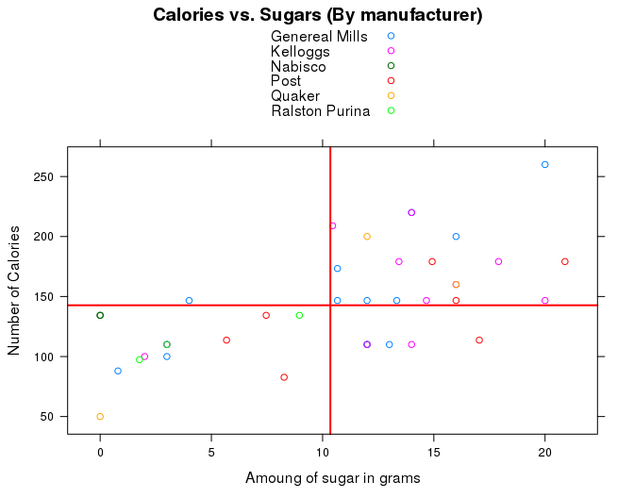

*Hint:* This plot uses data from the cereal data set. The vertical line shows the average amount of sugar and the horizonal line shows the average number of calories.